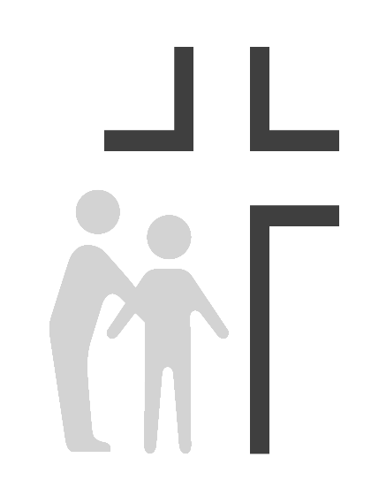
Good Samaritan Health Center of Cobb
Job Description
Chronic Care Coordinator
Medical Assistant/Scribe

Effective Date: | 06/19/2018 | Reports To: | Quality Director
SUMMARY OF DUTIES: The Chronic Care Coordinator performs care management for chronically ill patients with chronic diseases such as chronic kidney disease, diabetes mellitus, chronic obstructive pulmonary disease, and/or congestive heart failure. The Chronic Care Coordinator works in collaboration and continuous partnership with chronically ill patients and their family/caregiver(s), clinic providers and community resources in a team approach to increase patients’ ability for self-management and shared decision-making.
PRIMARY RESPONSIBILITIES:
- Can fulfill the clinic’s mission to spread the love of Christ through quality healthcare to those in need while providing appropriate physical, emotional, and spiritual care for the whole person.
- Responsible for registry of chronic care management (CCM) patients.
- Validates enrollment of CCM patients based on provider request
- Conducts minimum of one 20 minute of telephone or in-person counseling and education per month to each CCM patient on roster.
- Complies with documentation requirements of the Chronic Care Management program by carrying out the care plan with the patient, family/caregiver(s) and providers and recording in the EHR.
- Monitors adherence to care plans, evaluates effectiveness, monitors patient progress in a timely manner, and facilitates changes as needed.
- Creates an ongoing process for patient and family/caregivers(s) to determine and request the level of care coordination support they desire.
- Facilitates patient access to appropriate medical and specialty providers.
- Coordinates transition of inpatient to outpatient care in an effort to decrease readmission rates
- Work closely with in-office providers to manage the day to day calls involving: symptom control, medication management, and provide patient and family education
- Educates patient and family/caregiver(s) about relevant community resources.
- Assist with the identification of “high-risk” patients (the chronically ill and those with special health care needs), and assist on the enrollment of these to the patient registry.
- Coordinates continuity of patient care with external healthcare organizations and facilities including from the primary care provider to a specialty care provider.
- Supports patient self-management of disease and behavior modification interventions.
- Provides patient health counseling, education and instruction.
EDUCATION:
- Graduate from accredited School of Nursing
- Current LPN or RN license for the state of Georgia.
EXPERIENCE:

- Minimum of 1-3 year work experience in a healthcare setting involving patients with complex chronic disease states preferred.
- Bilingual Spanish required.

SKILLS:
- Strong working knowledge of chronic disease states including chronic kidney disease, diabetes mellitus, chronic obstructive pulmonary disease, and congestive heart failure and basic medical management of these states
- Must be highly motivated, result-oriented with strong skills in presenting, communicating, organizing, multi-tasking and time management skills
- Strong organizational and interpersonal skills
- Excellent customer service skills demonstrated by positive feedback from patients/team.
- Ability to identify problems and recommend solutions
- Ability to read, write and communicate effectively orally and in writing
- Basic computer skills including previous work with an electronic health record (EHR)
ENVIRONMENTAL/ WORKING CONDITIONS:

- Combination of medical office and exam / procedure room setting which is a well-lit, well-ventilated, adequate space.

PHYSICAL/ MENTAL DEMANDS:

- Must be able to use appropriate body mechanics techniques when making necessary patient transfers and helping patients with walking, dressing, etc. Must be able to lift up to 40 pounds.
- Hearing / Speaking: Effective communications with patients, staff and visitors.
- Standing: 40% of the workday
- Sitting: 20% of the workday
- Walking: 30% of the workday
- Lifting: 10% of the workday

This description is intended to provide only basic guidelines for meeting job requirements. Responsibilities, knowledge, skills, abilities and working conditions may change as needs evolve.

