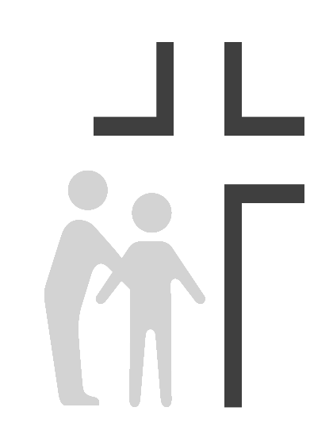
Good Samaritan Health Center of Cobb
Job Description
Medical Assistant/Scribe

Effective Date: | 01/01/2021 | Reports To: | Floor Manager/Medical Director
Review Date: | 01/01/2023
SUMMARY OF DUTIES: Responsible for assisting providers with, clerical, environmental, and clinical tasks related to providing high quality patient care. Provides information to patients so they may fully utilize and benefit from clinic services.
SUPERVISION RECEIVED: Reports to Floor Manager/Medical Director, and also takes direction from professional and medical staff to include volunteer providers, Physicians, Nurse Practitioners, and Physician Assistants.
SUPERVISION EXERCISED: MA students and volunteers as needed.
PRIMARY RESPONSIBILITIES:
- Can fulfill the clinic’s mission to spread the love of Christ through quality healthcare to those in need while providing appropriate physical, emotional, and spiritual care for the whole person.
- Serve as an assistant to physician focusing on documentation of patient charts and will accompany physician into patient rooms to ensure thorough documentation in electronic medical records
- Work closely with providers to supply real time charting and a variety of other clerical tasks including medical records, documenting results of diagnostics tests, etc.
- Fulfills patient care responsibilities as assigned which may include: accompanying patients to exam / procedure room, administering shots, assisting patients as needed with walking, transfers, dressing, collecting specimens, preparing for exam, etc., collecting patient history, performing screenings per provider guidelines, assisting physicians / nurses with various procedures, charting, relaying instructions to patients / families, answering calls and providing pertinent information.
- Fulfills other responsibilities as assigned which may include: sending / receiving patient medical records, obtaining lab / x-ray reports, hospital notes, referral information, etc., completing forms / requisitions as needed, managing charts to ensure information is completed and filed appropriately. Order vaccines and drugs as needed.
- Fulfills environmental responsibilities as assigned which may include: setting up instruments and equipment according to department protocol, cleaning exam / procedure rooms, instruments and equipment between patient visits to maintain infection control, cleaning sterilizer according to scheduled maintenance program and keeping appropriate records, ordering, sorting, storing supplies, restocking exam / procedure rooms.
- Responsible for routine clinical duties such as taking vital signs, performing simple diagnostic tests, collecting specimens, drawing blood, sterilizing and cleaning equipment, and maintaining examination rooms in an primary care setting
- Fulfills organizational responsibilities as assigned which may include: respecting / promoting patient rights, sharing problems relating to patients and / or staff with immediate supervisors quickly.
- Interprets for staff and patients.
- Assists in receiving, logging and collecting laboratory specimens. Prepares specimens for technical testing.
- Performs laboratory testing as directed.
- Files reports and laboratory results.
- Operates, cleans and sterilizes laboratory equipment, glassware and instruments. Cleans work area.
- Prepares equipment to efficiently collect blood products. Maintains adequate supplies.
- Performs venipuncture and capillary punctures on patients. Identifies and labels specimens. Conducts laboratory tests on specimens. Enters data into computer.
- Equipment maintenance, supplies, and follow-up for EKG, Spirometry, electronic blood pressure, and other equipment as acquired.
- Other duties as assigned by supervisor or medical director.
- Maintains patients' charts and records data, ensuring proper identification, documentation, routing, and confidentiality
- Maintains a clean and healthy environment in compliance with Universal Precaution guidelines and safety standards
- Performs other related responsibilities as required

The job holder must demonstrate current competencies applicable to job position.
EDUCATION:
- High school diploma, some college preferred. Graduate of an accredited medical assistance program.
EXPERIENCE:

- Minimum of one year work experience in a healthcare setting preferred. Bilingual Spanish preferred.

REQUIREMENTS:

- Maintains CPR certification. Obtains appropriate certificate indicating passing grade for specific specialty, e.g., Pediatric Medical Assistant exam. Computer literate.

KNOWLEDGE:

- Knowledge of health care field and medical specialty.
- Knowledge of specific assisting tasks related to particular medical specialty.
- Knowledge of information that must be conveyed to patients and families of diverse backgrounds.
- Knowledge of x-ray procedures and protocols.
- Knowledge of laboratory techniques to perform routine laboratory testing.
- Knowledge of laboratory equipment and testing to operate, clean and sterilize.
- Knowledge of phlebotomy techniques.

SKILLS:

- Skill in performing assistance tasks appropriately.
- Skill in diplomacy and tact in interpersonal interactions.
- Skill in understanding of patient education needs by effectively sharing information with patients and families of diverse backgrounds.
- Skill in operating a variety of laboratory instrumentation.

ABILITIES:

- Ability to learn and retain information regarding patient care procedures.
- Ability to project a pleasant and professional image.
- Ability to plan, prioritize and complete delegated tasks.
- Ability to demonstrate compassion and caring in dealing with others in a way that supports the Center’s mission to share the love of Christ through quality healthcare to those in need.

ENVIRONMENTAL/ WORKING CONDITIONS:

- Combination of medical office and exam / procedure room setting which is a well-lighted, well-ventilated, adequate space.
- Frequent exposure to communicable diseases, toxic substances, ionizing radiation, medicinal preparations and other conditions common to a clinic environment.
- This position is classified as a Category 1 position under OSHA guidelines with high risk of exposure to blood-borne pathogens and other potentially infectious materials.
PHYSICAL/ MENTAL DEMANDS:

- Must be able to use appropriate body mechanics techniques when making necessary patient transfers and helping patients with walking, dressing, etc. Must be able to lift up to 40 pounds.
- Hearing / Speaking: Effective communications with patients, staff and visitors.
- Standing: 40% of the workday
- Sitting: 20% of the workday
- Walking: 30% of the workday
- Lifting: 10% of the workday

This description is intended to provide only basic guidelines for meeting job requirements. Responsibilities, knowledge, skills, abilities and working conditions may change as needs evolve.

Acknowledgment

I have read and understand my job description, and I have discussed my job requirements and responsibilities with my supervisor.

Print Name

Employee Signature Date

